Copyright Healogics, LLC. 2021. All Rights Reserved.

WOUND CARE AWARENESS
Social media posts
Share the Wound Care Awareness message with your network on social media. Use the hashtags #YearofHealing #WoundCareAwareness.

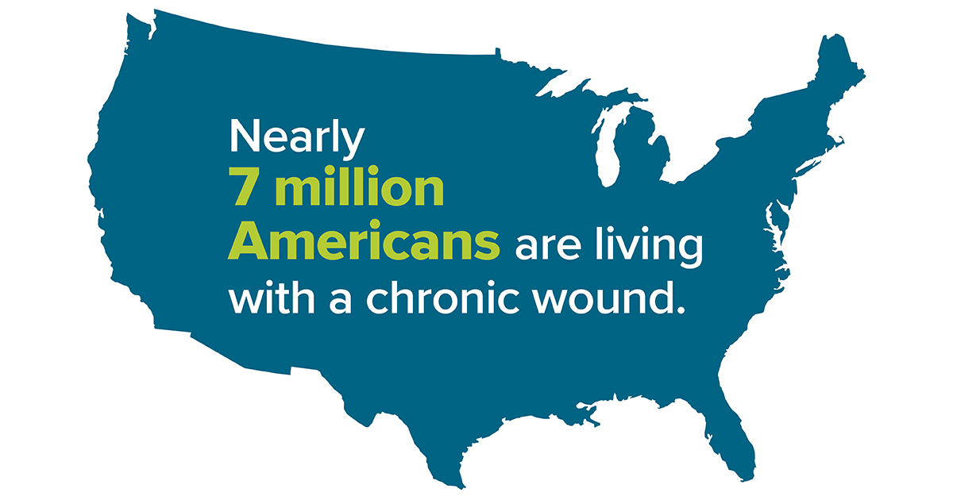

POST TEXT:
1 in 4 families has a family member with a non-healing wound. Spread the word about the importance of wound detection and advanced care.
#YearofHealing #WoundCareAwareness

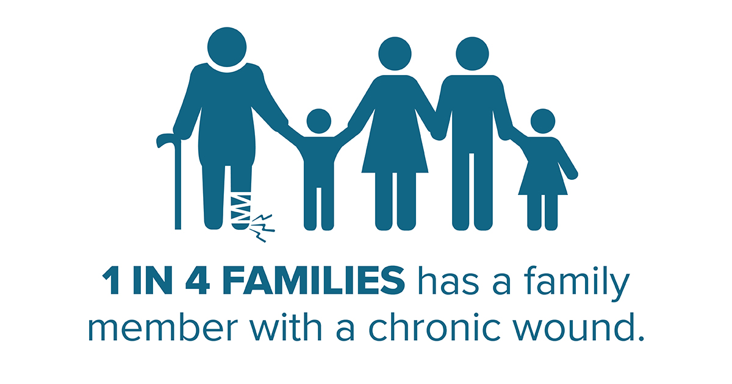

POST TEXT:
Chronic wounds are a growing healthcare problem with unrealized risks. Timely detection and treatment of any wound can help prevent severe complications.
#YearofHealing #WoundCareAwareness

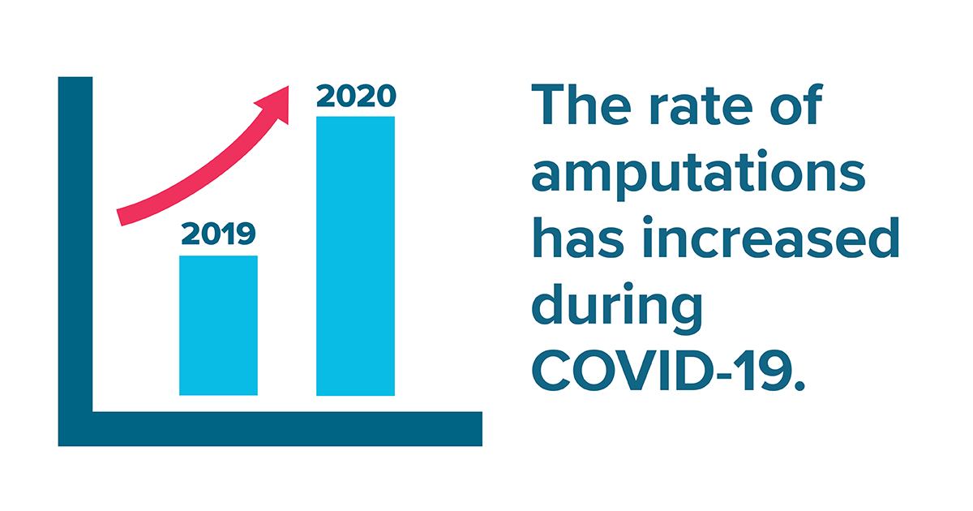

POST TEXT:
Increasing rates of amputation make it more important than ever to help spread the Wound Care Awareness message that wound care is essential. Read full article here.
#YearofHealing #WoundCareAwareness

POST TEXT:
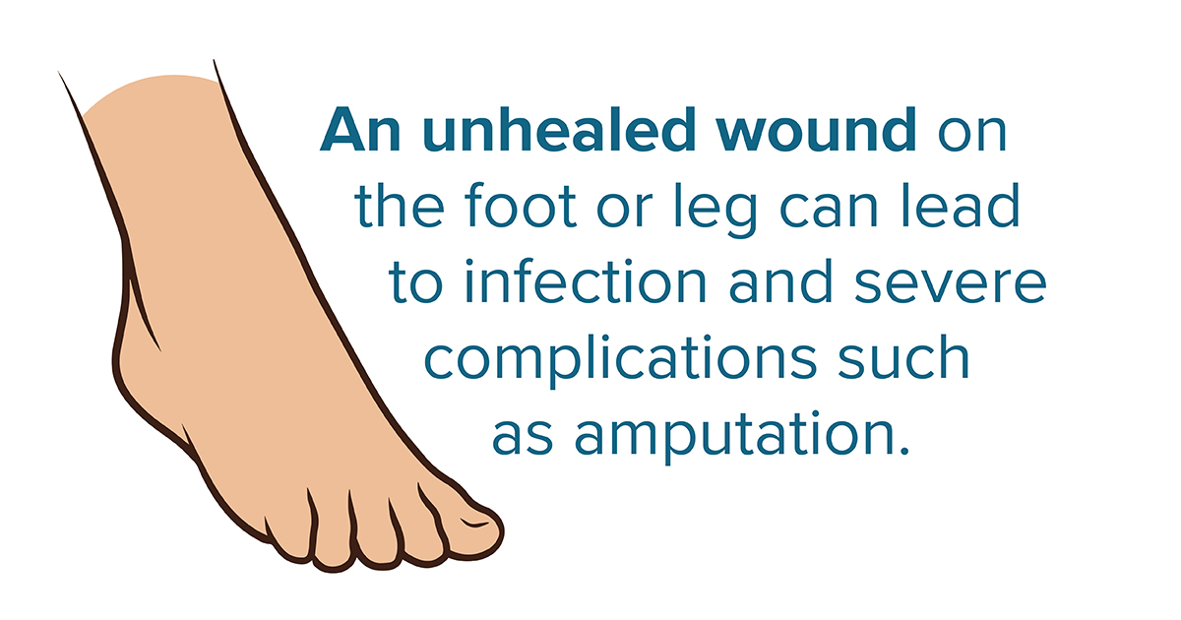
Good foot care and regular screenings can help prevent wounds. Learn more about wound prevention and advanced care at WoundCareAwareness.com
#YearofHealing #WoundCareAwareness

Property of Healogics 1810.1

